C#

Chapter 2
&
Using MS Visual Studio Express 2015

Summary
In Chapter 2 you will learn how to configure and use MS Visual Studio Express 2015 and how to write a basic C# program. You will learn about the structure of a C# program, and the files that are created for your programs. You will learn core functionality of MS Visual Studio Express 2015 that you will use whenever you write C# programs. You will develop a basic process for creating any new program that you create.

Below is a list of acronyms that are used in this document. Read them over now and refer back to them as needed.

- IDE – Integrated Development Environment
- RMB – Right Mouse Button
- C# - “C Sharp”
- .cs – the Class file extension
- .sln – the Solution file extension
- .csproj – the Project file extension
- .exe – the executable file extension
- OOP – Object Oriented Programming
- i.e. – “for example”

These notes contain some of the highlights of this chapter. You should add any additional notes on the page(s) at the end of this packet. If you run out of space, use loose leaf paper and put them after these pages. Include anything you feel is helpful or important from your work in this chapter.
Registering Microsoft Visual Studio Express 2015

- After install (the install is already done for you), start Microsoft Visual Studio Express 2015. (This application is your IDE “Integrated Development Environment”; you will use this program to write your programs instead of writing them in a text editor). 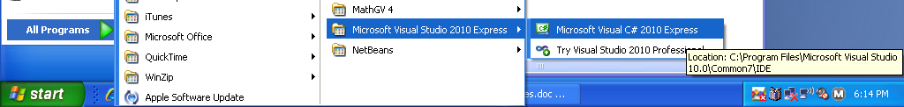

- The start screen should look like the picture below 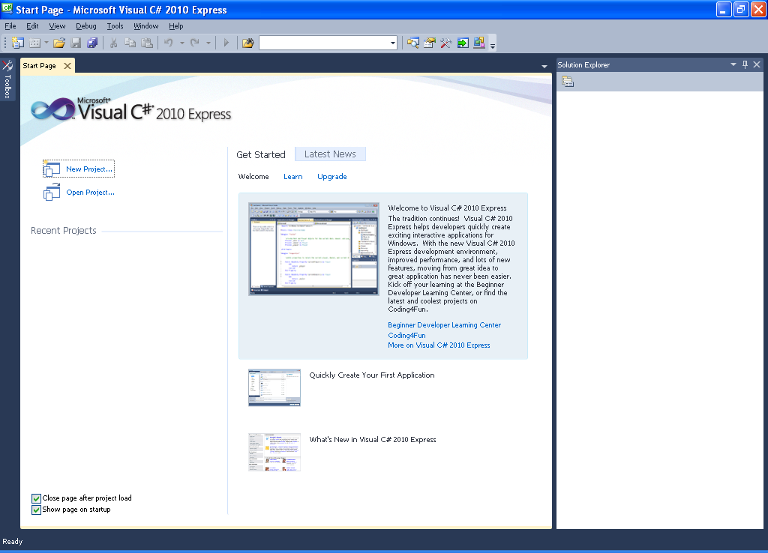
- Before working, we must register our product by creating a Windows Live ID. If you own an XBOX and play online you probably already have one and can use it here. If not, you will need to create a new Windows Live ID / Outlook account. Provide ‘fake’ information if you’d like. Just make sure you record your email ID and password. This needs to be done so we can continue to use this free software without interruption. 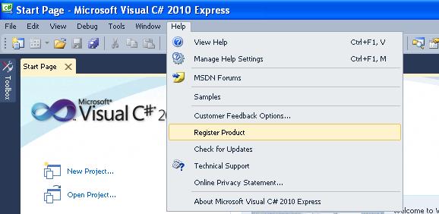

- When you get your registration code in your Hotmail account, follow the instructions in the email to register your copy. Save the email. You can also use it to register a copy on your home PC.

Configuring Microsoft Visual Studio Express 2015

Configuring common settings for your IDE will make it easier for you, your classmates and your instructor to help debug issues you have with your programs.

- After you have successfully registered your product. Start the application again and your screen should look like the picture below.

- Setting Your Common Programming Environment
- In order to work efficiently, you will choose the following settings in your environment:
  - Default Location for your projects
    - “Tools > Options”
    - {expand} “Projects & Solutions”, then select “General”
      - Check “Save New Projects When Created” if it already is not checked
      - In the field labeled “Project location” enter “H:\<lastnameID> \Computer Science\Projects”
Ex: “H:\Lynch100845\Computer Science\Projects”
      - In the field labeled “User project templates location” enter “H:\<lastnameID> \Computer Science\ProjectTemplates”
      - In the field labeled “User item templates location” enter “H:\<lastnameID> \Computer Science\ItemTemplates”
  - Turn Line Numbers On
    - “Tools > Options > {expand} Text Editor > {select} C# > {select} General”
    - Check the box “Line numbers” & click “OK”
  - Set a Common Display
    - “View > Error List”
    - “View > Properties Window”
  - Common Toolbars
    - “View > Toolbars > Debug”
      - Drag this toolbar to the top right
    - “View > Toolbars > Text Editor”
- Your screen should now look like the picture below. If it does then you are done.
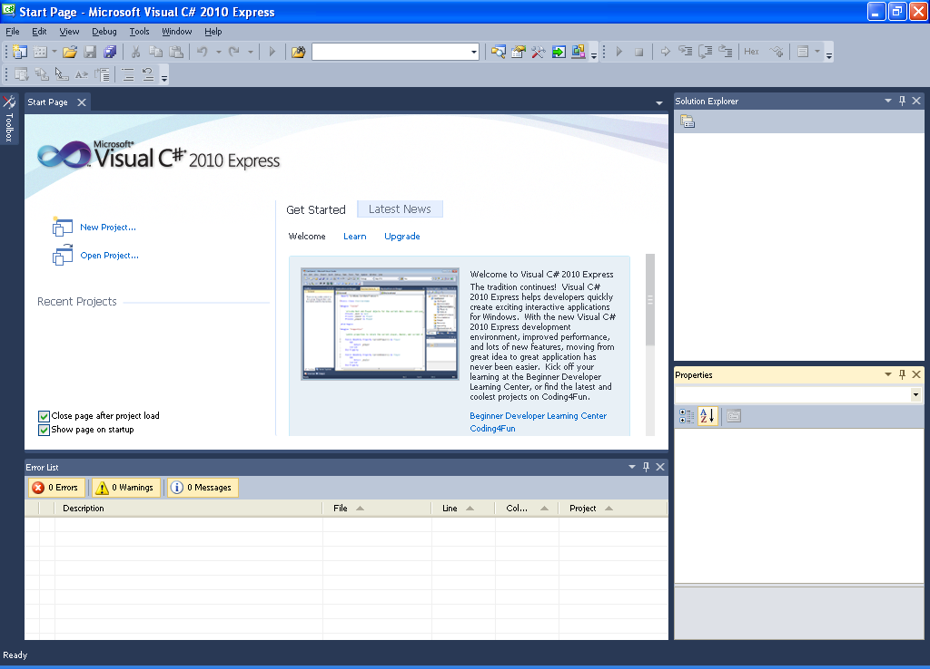

Understanding Solutions, Projects, Files & Basic Program Structure

MS Visual Studio Express does lots of dirty work for you that saves time if you’d have to create everything from scratch. It builds a folder structure, creates several files, and writes several lines of code that are needed in every program you would write.

Solutions
Think of Solutions as folders or containers that hold 1 or more Projects. Quite often your Solution will only have 1 Project. When we start doing more advanced coding, your Solution will have multiple Projects in it.

Projects
Think of projects as folders or containers where the actual program files that you create are put.

Process of Creating Solutions / Projects / Programs
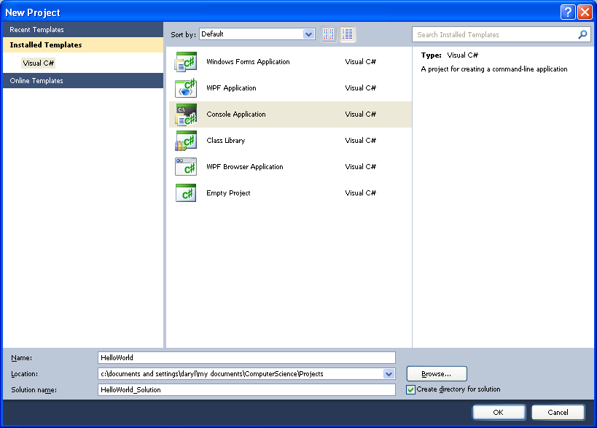
When you work on a new program you create a New Project. When you do this, the Solution {container} and its entire sub-folder structure are automatically created. In other words, whenever you are creating a new program you always do “File > New Project”. The picture below shows what this screen should look like if you entered “HelloWorld” in the ‘Name’ field and entered “HelloWorld_Solution” in the ‘Solution name’ field (your name is a descriptive name for your project. Make it unique and useful. Don’t use spaces or special characters and don’t start with a number). Always append “_Solution” to the Solution Name after you have entered the ‘Name’ field. (We will always select either ‘Console Application’ or ‘Windows Forms Application’. CS 1 students will usually be writing console applications while CS 2 students will learn to write Windows forms application).

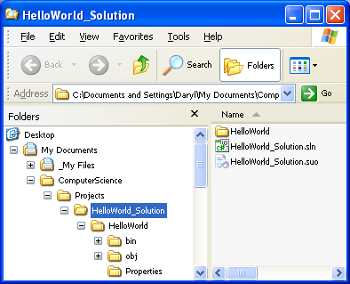
The picture on the left shows what gets created in your directory when you create a new project. Note, it creates a Parent Folder with the ‘Solution Name’ (called ‘HelloWorld_Solution’ for this example), a sub-folder with the Project ‘Name’ (called ‘HelloWorld’ for this example) and 3 folders under the Project folder that are needed by C# but that we won’t be concerned with at this time. Also note the files that are created in the Solution folder. These files contain solution attributes about your solution and are needed by C#.

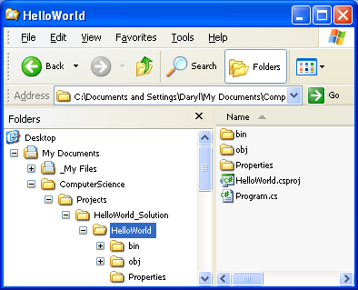
The picture on the right has the project folder selected and shows 2 files. One is your attribute file for your project (“HelloWorld.csproj”), the other is your actual code/program that you are writing (Program.cs). {Well it’s about time we get down to business!!!}. So when you write your code it gets saved in the ‘program.cs’. The generic name ‘program.cs’ is useless and we will always rename it to something more descriptive. (“.cs” stands for ‘class’; more on this later). Never use spaces or special characters and never start with a number. If your name is more that one word use “PascalCasing”.

How “Solutions, Projects, Namespaces, Classes, & Your Code” are Related

Solution
- This is the TOP LEVEL of your work.

Project
- A Solution may contain many Projects (but at least one)
- A project contains all the files and configuration data required to create your end product, and an executable .exe or .dll file. In the world of the .NET Framework, this is referred to as an assembly.
- You don't have to understand all the details about projects before you begin writing code. In fact, for simple applications, you can usually just accept the default project settings. But at some point, you might want to change the name of your executable file, customize some aspect of the build process, add a reference to a .dll, or strengthen the security settings. To make these changes, you will be using Solution Explorer, a window which displays all your project items in one convenient area.

Namespace
  - A Project may contain many Namespaces (but at least one)
  - When you create a new Project, the project name is automatically assigned to the Namespace name. For most of our projects we will leave this as is.
  - ADVANCED: Namespaces are a way of organizing the various types that occur in a C# program. It is somewhat similar in concept to a folder in a computer file system. Like folders, namespaces enable classes to have a unique fully-qualified name. A C# program contains one or more namespaces, and each namespace is either defined by you the programmer, or defined as part of a previously written class library.
  - ADVANCED: Create a separate folder for each namespace.
  - ADVANCED: It is common to use namespaces when working on large programs.
  - For example: assume you are writing an application that loads both statistical data and image files from a disk. You could create two new namespaces, one called Images and one called StatisticalData.
  - To add a new project to a solution, select the solution in the Solution Explorer and RMB > Add > New Project.

Class
- Everything is designed around classes. They are the building blocks of Object Oriented programming.
- Every program MUST have at least one class.
- A Namespace can have many classes (but a least one).
- Each Class should have its own file (*.cs).
- Classes contain: methods, variables, constants…
- Class is the template from which objects are instantiated (advanced topic).
- .NET has many predefined classes that you will use (i.e. Console.WriteLine).
- It is tradition to name the file containing the class the same name as the class name.
  - This is why we rename the ‘Program.cs’ file to a name that describes our program.
- A project may have multiple class (*.cs) files.
- To create a new class file under an existing project, select the project in the Solution Explorer and RMB > Add > Class.

Main() Method
- Your class file MUST contain a Main( ) method.
- This is where the program begins and end execution.
- The Main program is denoted by everything between the curly braces { } that are after the line “Main ( )”.

Method Body – Statements
- Contains your program
- Declare variables & constants (types – int, string, etc.).
- Program logic: loops, decisions, arrays, etc.
- Calls to other methods (your own or .NET predefined methods) - read, writing, performing calculations …

Custom Methods – Statements (We’ll work on these later)
- They exists outside of the Main { }.
- They are like mini-programs (subroutines).
- They can be called over & over again (re-use).
- These methods are called from within the Main { } or other Methods.
- A method may or may not need information sent to it.
- A method may or may not send information back to where it was called from.

Activity - Creating Your First Program “HelloWorld”
- File > New Project.
- Select ‘Console Application’.
- In the ‘Name:’ field enter HelloWorld (Never start your name with a number and don’t use any spaces).
- In the ‘Solution name:’ field enter HelloWorld_Solution.
- Make sure ‘Create directory for solution’ is checked and click ‘OK’.
- In your solution explorer, rename ‘Program.cs’ to ‘HelloWorld.cs’ (click ‘Yes’ when prompted to rename references).
- Go to the OS and find the set of folders that have been created for your solution. Examine the folders and sub-folders and become familiar with them.
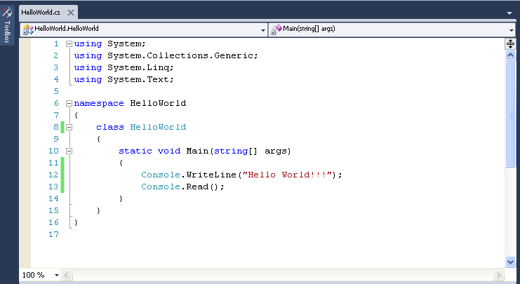
- Back in your program; notice the code that gets automatically created when you create a new console application (we’ll call this the program framework). You will add 2 lines of code (lines 12 & 13 in the image below) and make your program look like that program shown below. NOTE: that the line numbers are only for reference and don’t need to match.

- Entering Code: Note when you are entering code your IDE does several things to make this job easier and more efficient. Such as
  - Automatically indenting your line of text to the correct location. This makes your code easier to read. Don’t fight what the IDE is doing for you. If it seems to be putting your text in the wrong location, then you probably are missing some { }, have too many { }, or are missing the “;” at the end of the line above.
  - Auto-completing with IntelliSense. Just like when you do a search on Google and it tries to guess what you are going to enter by showing you a list of possible choices, your IDE tries to do the same thing. Why type the entire word/phase. Save yourself the time and just pick it from the list it gives you (easily done by just hitting the tab key if it’s highlighted in the list; else just double-click it). You’ll also notice that the IDE gets smarter in generating you a list based on what commands you use most often.
  - Real-Time error listing. As your type in your code, the Error List window shows you descriptions of errors in your code as you type. You typically want to wait to evaluate the information in the Error window until you complete typing in a line of code. This is because if you type in a line slowly, it may think you are done typing and show an error that would probably go away if you finished typing in the line. When trying to diagnose an error in your “Error List” window just double-click on the error and your cursor will jump directly to the line that the error refers to.
  - Vertical Color Bar: track changes since last time compiled. Yellow has been changed. Green has not.

- Code Regions: Along the left edge of the code window, you see several small plus (+) and minus (-) signs in boxes. Click them to see what happens. They expand and contract regions of your code. These Code Regions help you focus on the code you’re working in by hiding code that you aren’t working on. Notice that some code regions are defined automatically when you create a new program. You can define your own code region by entering the line #region above a section of code and #endregion after it. It also helps to name the region with a brief description after the #region. For example, if you wanted to make the code you typed in for this activity as a region you might enter #region <description> above the ‘writeline’ line, and #endregion below the ‘read’ line. This is a very handy tool as your programs become larger. You can easily create a Region by using highlighting the region of code and using the Code Snippet for #Region.

- Comments: any line of code that begins with // is a free text comment and is ignored by C#. So why include lines if the computer ignores them…because comments explain your C# statements. A C# program is not easy to understand. As you write larger programs, comments will be vital for you to be able to understand what you intended a portion of code to do. They are also extremely useful for anyone that is trying to provide you help on why your code does not work or anyone that is going to use your code at some later time. Use the RMB to quickly comment & uncomment lines of code for testing. You can also put a comment on the same line as code, just put // after your code (only use for short lines of code, remember to keep your line less then 80 characters. Your column number is shown on the bottom of the screen).

- Code Snippets: You can save loads of typing time by using code snippets. They are great for common statements like ‘Console.WriteLine’ and many more. To get to this list, hit RMB then ‘Insert Snippet’ then ‘Visual C#’, and select your snippet of code you wish to insert (‘cw’ is the snippet for ‘Console.WriteLine’). This feature becomes more useful as we learn more and more functions. (Advanced: cw, Tab, Tab)
  - Hint: after you commit a code snippet to memory, the shortcut for inserting it is: <code letters>, Tab, Tab
    - i.e. CW, <tab>, <tab>

- Toolbox: You will find that as you write your programs that there are often several lines of code that you use over and over again in lots of different programs. You can store these lines of code in your toolbox and reuse them later without typing anything in. Just make sure your toolbox window is open, select the lines from your code, drag and drop them onto your toolbox window. You can use the RMB and rename the piece of code for easier reference later. To use code stored in your toolbox, just drag and drop it into your code from the toolbox.

Back to the Program…
- When done entering your code, build and run your program (compile & execute) by either pushing ‘F5’ or the 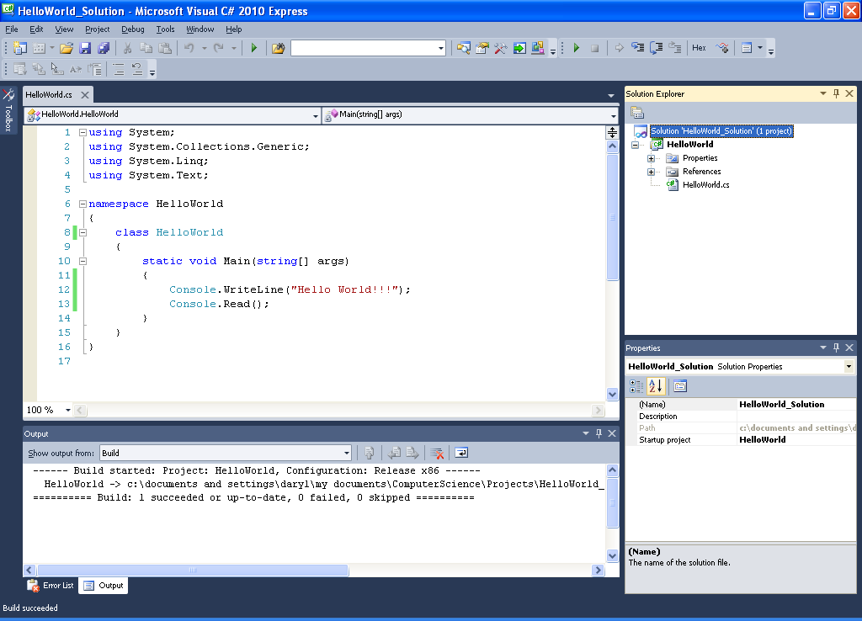 in your toolbar.
- Congratulations, you have just created your first C# program!!
- Click “File > Save All” and save your work.

HOW TO: Create a New Solution
- File > New Project.
- Select ‘Console Application’.
- In the ‘Name:’ field enter <name of your project> (Never start your name with a number and don’t use any spaces).
- In the ‘Solution name:’ field enter <name of your project>_Solution.
- Make sure ‘Create directory for solution’ is checked and click ‘OK’.
- Done!

HOW TO: Rename Your ‘Program.cs’ File
- In your solution explorer, RMB on ‘Program.cs’, Rename, enter a name. Typically you will enter the same name as the project (You can’t start with a number or have any spaces!)
- When you rename the Program.cs file you will be prompted with the message below. 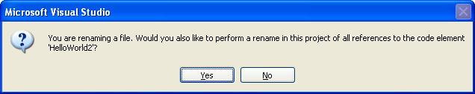Select ‘Yes’ to rename all references. Notice that the line in your code that says “class Program”, now says “class <new name>”.
  - NEVER rename your “Program.cs” file from the operating system directory; if you do your solution file will not be able to find it when you open the solution and you will get errors.

- Advanced: As we write more advanced projects with multiple classes, you will rename these files with more appropriate names.

HOW TO: Save Your Work
- Save you first solution by doing ‘File > Save All’ or by clicking the icon.
- Always use ‘Save All’ , NEVER ‘Save’. This will ensure that you will not lose any of your work by maintaining all the proper links between all the files/folders needed by your solution.

HOW TO: Working on Existing Projects / Solutions / Programs
- When working on existing solutions…
  - Always do: “File > Open > Project”
  - Go to the Solution folder and open the “*.sln” file
    - This will make sure that all the reference files needed for your program to work are also loaded.
  - If your code is not displayed in the main window after opening the solution, just double-click on the “.cs” file in the Solution Explorer” window.
  - NEVER CHOOSE “File > Open File…”. This will most likely cause confusion on what you are actually working on and your program will most likely not run since all the files it requires to run are not loaded.

- It is recommended that you DO NOT double-click on any file in the OS to open it up. This is because if you already have an instance of MS Visual Studio running it will launch a second instance of MS Visual Studio which will hog up all of you PC’s RAM and make it run really, really, really slooooooooow. Unlike other applications, you can’t have more than 1 project open at the same time.

HOW TO: Move Your Solution / Project / Program to Another Location
- You may need to copy your solution to another location so you can work on it outside of class or on another PC. In order to do this just copy the entire Solution folder to another location. As long as you open the “.sln” file, MS Visual Studio will be able to re-connect all the links between the files and load everything properly.

HOW TO: Renaming Your Solution / Project / Program
- The simple rule for renaming ANY of your C# files is to do it from within the MS Visual Studio interface.
  - Renaming files at the operating system level will cause unpredictable results.
- DON’T EVER RENAME C# FOLDERS!!!
  - You can’t rename the folders created by C#. If you do you will get errors when trying to load your solution.
  - From the OS, you can only rename the top level solution folder. If you rename any other folders you will get errors.
  - Note: renaming solutions or projects in the interface WILL NOT rename the folders already created in the operating system.

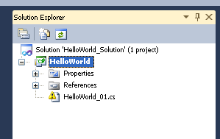
- ERROR: If you rename the ‘Program.cs’ file from the OS your solution explorer will show you the following image (it means that it was not able to find the file):

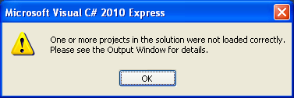
- ERROR: If you rename a folder from the OS you will get the following error when loading your solution.

APPENDIX A: Special Characters - “Escape Sequences”

\n | New Line | \a | A beep sound
\t | Tab | \’ | Single quote
\0 | A blank space | \” | Double quote
\r | Carriage return | \\ | Backslash

APPENDIX B: Program Header Comments
Every program file you write should start with header information in the form of a Multiline / Block comments. It should include the filename, name of author, a brief description of the program. A sample block comment is shown below, you should use this format when writing your programs.

/* <filename.cs> Author: <Your Name>
* This program will...
* <description of program here and on next
* several lines as needed. >
***********************************************************/
APPENDIX C: MISCELLENAOUS TIPS
- When entering a new line of code, put your cursor at the end of the line above where you want to enter your new line and hit ‘Enter’. Now start typing and watch as it auto indents for you. Niiiiiiice!!!
- Colors in MS Vis Studio
  - Lt Blue color words are classes
  - Blue color words are Keywords
  - Red color words are string text
- C# is CaSe-SeNsItIve !!!!!!!
- When showing the class a program on the overhead, go to ‘View -> Full Screen’ and change the Percentage from 100% to something larger.

YOUR CHAPTER 2 NOTES
In this space write any important notes that you have learned from answering the chapter exercises, writing the programming exercises, from the Quick Review, or from any class discussions.
YOUR CHAPTER 2 NOTES (continued)
In this space write any important notes that you have learned from answering the chapter exercises, writing the programming exercises, from the Quick Review, or from any class discussions.

